 |  |   Year 5 Spring 2  Judaism  Why is the Torah so important to Jewish people?
 |  | Vocabulary
Need to know:  - The Torah has 613 rules that Jews should follow including what they can and cannot eat.  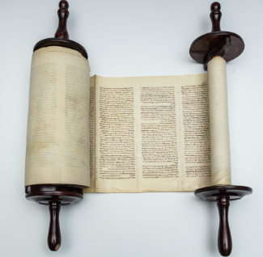 | Nice to know:  - The Jewish community is diverse.  - Jews believe in one God.  - Jews believe one should worship God with all one’s heart.  - The Torah is treated with respect and ritual. | Sefer Torah | Is a handwritten copy of the Torah, meaning the first five books of Moses.
 |  | Pesach/Passover | Is a celebration of the story of Exodus. During Passover, Jews remember how their ancestor’s left slavery behind them when they were led out by Moses
 |  | Exodus | The story of Moses’ journey where he led all of the Israelites out of Egypt, across the Red Sea, to freedom in the wilderness.
 |  | Kosher | The laws about the kind of food that the Jewish may eat.
 |  | Orthodox Judaism | Is a form of Judaism that interprets the teachings and scriptures in a stricter way than the rest of Judaism.
 |  | Ten Commandments | Laws spoken by God to Moses on Mount Sinai and then written on stone tablets by the ‘finger of God’ They are a set of biblical principles relating to ethics and worship.

