 |  |   Year 6 Spring 2  Christianity-Salvation  What do Christians believe Jesus did gto save people?
 |  | Vocabulary
Need to know:  - Christians believe that Jesus’ death was a sacrifice. (Salvation)  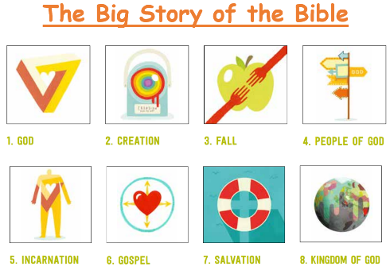 | Nice to know:  - Christians read the ‘big story’ of the Bible as pointing out the need for God to save people. This salvation includes the ongoing restoration of humans’ relationship with God.  - Christians believe that Jesus’ death was a sacrifice.  - Christians remember Jesus’ sacrifice through the service of Holy Communion (also called the Lords Supper, the Eucharist or the Mass.  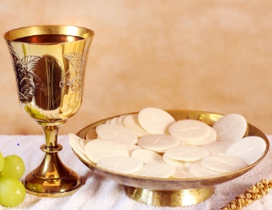  - Symbols used within communion are bread and wine. | Salvation | Being saved from sin, and to have eternal life with God in Heaven after death
 |  | Communion/  Eucharist | A religious ritual in many Christian churches and a time to remember the incredible sacrifice that Jesus made.
 |  | Holy Week | The last week of the 40 days of Lent. It is the week before Easter Sunday. It starts with Palm Sunday and ends with Holy Saturday.
 |  | Sacrifice | A loss or something you give up. Usually for the sake of a better cause.
 |  | Martyr | Is a person that dies for someone or something they believe in.
 |  | Restoration | To return something to a better state

