 |  | Year 1 Summer 1  Christianity  Who do Christians say made the world?
 |  | Vocabulary
Need to know:  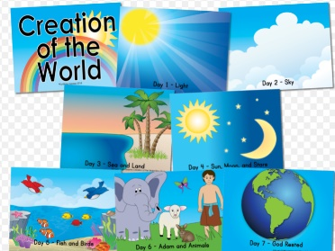  - Recognise that ‘Creation’ is the beginning of the ‘big story’ of the Bible. | Nice to know:  - Retell the story of creation from Genesis 1:1–2.3 simply  - Christians believe that we should look after the world because God created it. | Creation | 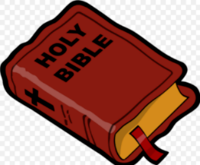  The first story of the Bible about how God created the world.
 |  | Grace | Christians say grace to remind them to be thankful to God for all the good things, even food and drink..
 |  | God | Christians believe in one Gof who created all things.
 |  | Genesis | A Genesis is the first book of the Bible.

