 |  |   Year 3 Summer 1  Christianity- Gospel  What kind of world did Jesus want?
 |  | Vocabulary
Need to know:  - The Gospels tell us that Jesus said we should ‘love one another’   | Nice to know:  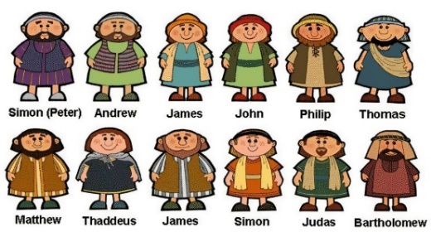  - Make clear links between the calling of the first disciples and how Christians today try to follow Jesus and be ‘fishers of people’.  - The things Jesus did show Christians how they should behave | Disciples | A dedicated follower of Jesus.
 |  | Leprosy | Is an infectious disease.
 |  | Community | A community is a group of people living in the same area. People in communities might go to the same school, shops and do the same things.
 |  | Fisher of men | A fisher of men is someone who looks at the lost people around him or her and sees the future disciples of Jesus
 |  | New Testament | The second part of the bible, written about Jesus’ life and the establishment of the church.
 |  | Gospels | A The first four books of the Bible’s New Testament that describe the life, death and resurrection of Jesus.

