 |  |   Year 4 Summer 1  Christianity-Kingdom of God  For Christians, when Jesus left, what was the impact of Pentecost?
 |  | Vocabulary
Need to know:  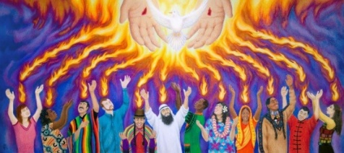  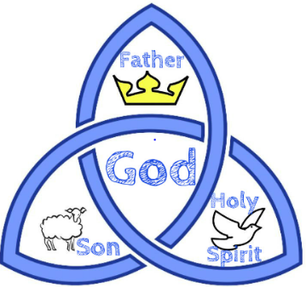  - The Holy Spirit is one part of the Trinity | Nice to know:  - Pentecost is the start of the church year.  - Pentecost is Christian festival that celebrates the descent of the holy spirit on the disciples.  - Pentecost is a Christian festival that celebrates the descent of the holy spirit on the disciples.  - Pentecost is the birthday of the Christian church. | Kingdom of God | The Kingdom of God is not a country or land, but wherever God is ruler of human lives. Whoever calls God their King and follows Gods way is a part of this Kingdom.
 |  | Apostle | Jesus chose twelve men from among his followers to be his apostles. An apostle of Jesus Christ is a messenger sent to spread the gospel of salvation. The apostles were sometimes referred to as ‘The Twelve’
 |  | Holy Spirit | Is the third person of the Trinity; God as spiritually active in the world.
 |  | Gospels | Historical documents that make up the first four books of the bible
 |  | Pentecost | A celebration for Christians. It is considered the churches birthday, where the Holy Spirit empowered the early disciples to preach about the Gospels.

