 |  |   Year 6 Summer 1  Christianity-Kingdom of God  Fora Christians, what kind of king is Jesus?
 |  | Vocabulary
Need to know:  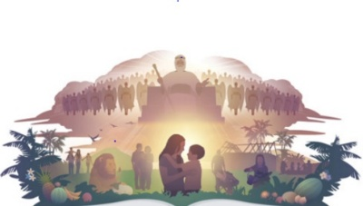  - Christians believe ‘the kingdom of God’ is a better world. | Nice to know:  - Jesus is a different type of king.  - Christians believe that Jesus was a king, who put others ahead of himself.   | Kingdom of God | The Kingdom of God is not a country or land, but wherever God is ruler of human’s lives. Whoever calls God their king and follows Gods way is part of this kingdom.
 |  | Gospel | A The first four books of the Bibles New Testament.
 |  | Heaven | Is the place described in the Bible as God’s perfect home for his people who have been saved by faith in Jesus Christ.
 |  | Feast | To eat a lot of food at a large, special meal.
 |  | Society | Is A community or group of people having common traditions, institutions and interests.

