 |  | Year 1 Summer 2  General  How should we care for others and for the world, and why does it matter?
 |  | Vocabulary
Need to know:  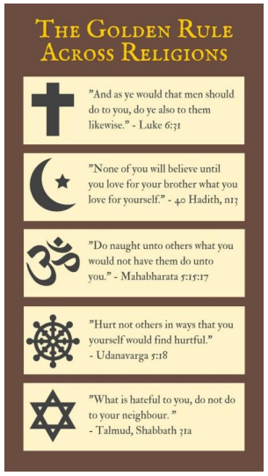  - The Golden Rule is the principle of treating others the way you would like to be treated. | Nice to know:  - Everyone is unique and special.  - Christians and Jews believe that God loves everyone.  - Believers and non-believers should look after the world.  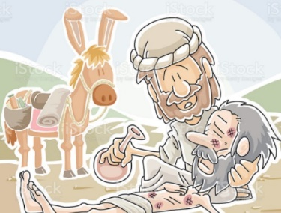  - Stewardship is looking after God’s creation. | The good samaritan | The Bible story of the Good Samaritan is a parable to demonstrate how we should “love our neighbours as ourselves.” The Good Samaritan was the person who had mercy upon the man that was half-dead and had been left on the side of the road.
 |  | Stewardship | The responsibility for looking after the world and God’s creation.
 |  | Charity | An organisation set up to provide help and raise money for those in need.

