 |  | Year 2 Summer 2  General  What makes some places sacred to believers?
 |  | Vocabulary
Need to know:  - Special religious places provide a place for faith communities to learn, pray, reflect and worship. | Nice to know:  - Some Christians use churches as a place of worship and community.  - Muslims use mosques as a place of worship and community.  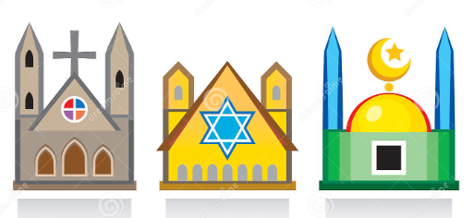  - Jews use synagogues as a place of worship and community | Font | The font is a stand that contains holy water in a basin which is used for baptism.
 |  | Alter | The focal point with where people offer prayers and sacrifices and the bread and wine are blessed to become the body and of Christ.
 |  | Pulpit | An elevated platform or high reading desk used in preaching or conducting a worship service.
 |  | Menorah | The seven-branched golden candelabra.
 |  | Ark | A cupboard where the Torah Scrolls, which contain the text of the Hebrew Bible, are kept.
 |  | Bimah | The raised platform in a synagogue from which the Torah is read.
 |  | Prayer hall | This is where Muslims come together to pray to Allah (PBUH)
 |  | Mihrab | A nook in the wall that shows the direction of Mecca.
 |  | Minbar | A raised platform in the front area of the mosque, from which sermons or speeches are given.

