 |  |   Year 3 Summer 2  General  How and why people try to make the world a better place?
 |  | Vocabulary
Need to know:  - We can all do something to make the world a better place.  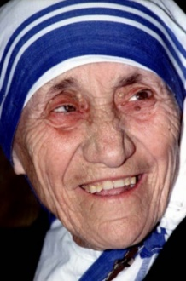 | Nice to know:  - Religions offer guidance or rules on how to live.  - Non-religious people also follow rules.  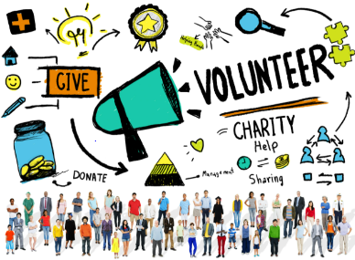  - Many people take action to make the world better. | The Golden Rule | The principle of treating others the way you would like to be treated.
 |  | Sin | Any deliberate action that goes against God’s law.
 |  | Humanist | Humanists do not believe in a god. They believe it is possible to live a good and fulfilling life without following a tradition or religion.
 |  | Tikkuh Olam (Jewish tradition) | Means “repairing the world” which can be as simple as walking a neighbours dog when he is sick.
 |  | Charity | An organisation set up to provide help and raise money for those in need.
 |  | Tradition | The transmission of customs or beliefs from generation to generation, or the fact of a being passed on in this way.
 |  | Mother Teresa | A Roman Catholic nun who devoted her life to serving the poor and destitute around the world.

