 |  |   Year 4 Summer 2  General  How and why do people mark the significant events of life?
 |  | Vocabulary
Need to know:  - Key milestones in life: starting/leaving school, baptism, marriage. | Nice to know:  - Many consider life as a journey.  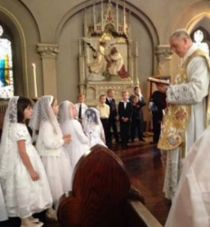  - Many milestones in life are marked by a ceremony. | Communicate | A promise or firm decision to do something.
 |  | Wedding | The legally or formally recognised union of two people as part  ners in a personal relationship.
 |  | Naamkaran | A naming ceremony that is very important Hindu ritual after the birth of a child.
 |  | Baptism | A ceremony that symbolises a commitment to living a life as a Christian.
 |  | Communion | A person’s reception of the sacrament of the Eucharist. Roman Catholics recognise the importance of this event as the Eucharist is the central focus of the sacramental life of the Catholic church.

