 |  |   Year 5 Summer 2  Christianity-Creation and science:  conflicting or complementary?
 |  | Vocabulary
Need to know:  - Christians believe that God created the world.  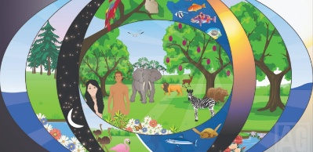 | Nice to know:  - Most Christians believe that the creation story is just a story to explain simply how God created the world.  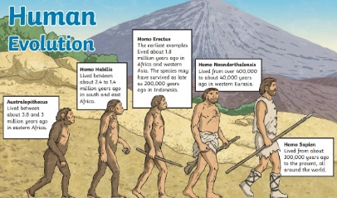  - The scientific view is that there was a big bang and that we developed through evolution.  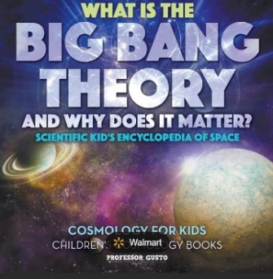 | Complementary | Something that complete or goes with something else.
 |  | Conflicting | The struggle and clash of interests, opinions or even principles.
 |  | Cosmology | The study of outer space or the universe
 |  | Evolution | The theory that all kinds of  Living things that exist today developed from earlier types.
 |  | Society | A community or nation of people having common traditions, institutions and collective activities and interests.

