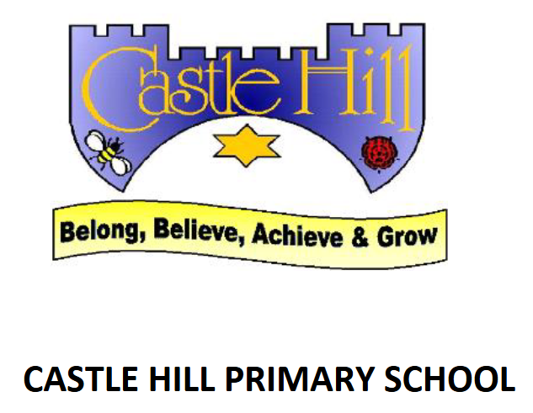
RSE Policy
Introduction
This Relationships and Sex Education (RSE) policy sets out the vision, aims, statutory requirements, and practical arrangements for RSE at Castle Hill Primary School. It is designed to ensure compliance with the 2014 National Curriculum, DfE Statutory Guidance (2019), and Ofsted Education Inspection Framework (2019), reflecting best practice and inspectorate expectations. RSE is delivered primarily through the JIGSAW scheme of work, which provides a spiral, progressive, and practical based approach. The JIGSAW scheme is taught weekly, with a particular focus on RSE content in Summer 2, when puberty and sex education are addressed. The policy is reviewed regularly in consultation with parents, pupils, and staff.
Aims
- To provide a high quality, age appropriate RSE curriculum that equips pupils with age-appropriate knowledge, language, skills, and attitudes to make informed decisions about relationships, health, and wellbeing.
- To promote respect, diversity, and understanding of consent in all relationships.
- To develop pupils’ resilience, self-esteem, and ability to manage emotions and risks.
- To support pupils in recognising and reporting abuse and unsafe situations, including online.
- To foster a safe, respectful, inclusive, and supportive learning environment for all pupils.
- To embed RSE across the curriculum and school culture, contributing to personal development and safeguarding.
- To ensure compliance with statutory requirements and reflect the values of Castle Hill Primary School.
Statutory Requirements
- Deliver Relationships Education as compulsory for all pupils, as per the Children and Social Work Act 2017.
- Provide Health Education, including physical and mental wellbeing.
- Teach statutory content areas: families, friendships, respectful relationships, online relationships, being safe, growing and changing (including puberty).
- Ensure RSE is inclusive and accessible to all pupils, including those with SEND and protected characteristics (Equality Act 2010, SEND Code of Practice 2015).
- Integrate RSE with safeguarding, teaching pupils how to stay safe (Keeping Children Safe in Education 2023).
- Enable parental right to withdraw from sex education (non-statutory in primary), except for content within the National Curriculum for Science.
- Publish the RSE policy and consult with parents regularly.
Curriculum Coverage
"Jigsaw is more than a scheme of work for PSHE. It is a whole-school philosophy with children and young people at its heart, which nurtures the positive and inclusive culture of the whole school community."
The JIGSAW scheme of work provides a comprehensive, spiral curriculum for RSE. The scheme is structured into six half-termly units (Puzzles) each year, with RSE content woven throughout and a particular focus in Summer 2:
- Being Me in My World: Identity, belonging, and understanding self and others.
- Celebrating Difference: Diversity, anti-bullying, and respecting differences.
- Dreams and Goals: Aspirations, resilience, and working together.
- Healthy Me: Physical and mental health, safety, and managing risk.
- Relationships: Qualities of healthy relationships, friendships, and families.
- Changing Me (Summer 2): Growing up, puberty, body changes, emotional transitions, and (where appropriate) basic facts about human reproduction.
Summer 2 (Changing Me) is when the statutory content on puberty is delivered. Sex education (non-statutory) is also offered at this time, with parental consent sought in advance. Letters are sent home to parents in Summer 2 to inform them of the content and their right to withdraw from sex education lessons.
Curriculum Implementation
- RSE is taught using the JIGSAW scheme of work, which is quality-assured and evidence-based.
- JIGSAW lessons are sequenced to ensure consistent, progressive coverage of RSE topics.
- Each lesson follows the JIGSAW structure: Connect Us (Community building), Calm Me (Mindfulness), Open My Mind (Introduction), Tell Me or Show Me (Teaching), Let Me Learn (Activities), Help Me Reflect (Self Evaluation and Closure).
- Active learning strategies are used, including discussion, role play, scenarios, and problem-solving.
- Clear ground rules and confidentiality protocols are established in every lesson to create a safe environment using the JIGSAW charter.
- RSE is embedded across the curriculum, including links to Science, Computing, and PE.
- Puberty and sex education content is delivered in Summer 2, with letters sent home to parents to ensure consent and inform them of their right to withdraw.
- Pupil voice is actively sought through class discussions and pupil voice to shape provision.
- Resources are regularly reviewed for inclusivity, accuracy, and appropriateness.
Assessment
- Formative assessment is used throughout RSE lessons, including:
  - Teacher observation
  - Pupil self-assessment
  - Peer feedback
  - Work samples and portfolios (KS2 where appropriate)
- Summative assessment is conducted at the end of each Puzzle (unit) to gauge understanding and personal development.
- Assessment outcomes identify areas for further support.
- Evidence of progress includes pupil voice, engagement, and demonstration of positive attitudes and behaviours.

Roles and Responsibilities
Role | Responsibilities
PSHE Coordinator | Coordinates curriculum coverage, monitoring, staff training, and resource selection, leads parental consultation.
Class Teachers | Deliver RSE lessons following the JIGSAW scheme, adapt content for individual needs, create a safe and respectful classroom environment using the JIGSAW charter.
SENDCo | Supports differentiation and accessibility for SEND pupils and updates staff with any Safeguarding issues which may result to units being taught with greater sensitivity.
Senior Leaders | Introduce new units by leading whole-school launch assemblies; support the PSHE coordinator; ensure statutory requirements are met; promote a whole-school ethos of belonging and inclusion.
Pupils | Engage actively in lessons, contribute to shaping provision, respect ground rules
All Staff | Model positive behaviour and attitudes; ensure safeguarding procedures are followed; contribute to a positive school culture and support pupil wellbeing.
Parents/Carers | Participate in consultation, support learning at home, exercise right to withdraw if desired
Inclusion
- RSE is inclusive and accessible to all pupils, regardless of gender, race, religion, social or economic background, or disability, reflecting the Equality Act 2010 and SEND Code of Practice.
- JIGSAW lessons are differentiated/adapted to meet the needs of pupils with SEND and those with protected characteristics.
- Resources and teaching approaches reflect diversity in family structures, relationships, and identities.
- The curriculum promotes equality, diversity, and inclusion, reflecting the school’s context and the wider world.
- The JIGSAW Charter is referred to each lesson in order to promote a safe, respectful and inclusive learning environment where pupils are aware of their right to pass.
- Staff receive guidance and support to deliver inclusive PSHE education.
- Pupil voice is used to ensure content is relevant and respectful of all backgrounds.
Professional Development
- Regular CPD (where applicable) is provided on RSE, safeguarding, and curriculum updates.
- Training covers subject knowledge, confidence in delivery, handling sensitive issues, and safeguarding protocols.
- Staff are supported in using the JIGSAW scheme and adapting content for individual needs.
- New staff receive induction training in RSE policy and practice. A power point is used to outline JIGSAW’s key concepts and how it is implemented throughout school.
Inspectorate Expectations
- The RSE curriculum is coherently planned, sequenced, and ambitious, meeting Ofsted EIF criteria for quality of education.
- Content is age-appropriate, inclusive, and reflects statutory requirements and the Equality Act 2010.
- Pupils demonstrate secure understanding, positive attitudes, and ability to keep themselves safe.
- Assessment is used effectively to inform teaching and learning.
- Parental engagement is meaningful and ongoing, including consultation and communication about the right to withdraw.
- RSE is embedded across the curriculum and integrated with the school’s safeguarding strategy.
- Monitoring and evaluation systems are robust, including pupil voice and governor oversight.
Monitoring and Review
- The RSE policy and curriculum implementation are monitored by the PSHE/RSE Lead and Senior Leadership Team.
- Regular audits ensure full statutory coverage and progression.
- Pupil voice, parental feedback, and staff evaluation inform ongoing improvement.
- Governors review the policy annually and receive reports on effectiveness and compliance.
- The policy is reviewed at least annually, or sooner if statutory guidance changes.
Links to Other Policies
- PSHE Policy 2026
- Safeguarding and Child Protection Policy 2025
- Keeping Children Safe in Education 2025
- Pupil Mental Health and Wellbeing Policy 2025
- SEN Policy 2025
- Equality Policy 2024
- Behaviour Management Policy 2024
- Anti-Bullying Policy 2024
- Science Curriculum Policy 2026
- Online Safety Policy

Updated by Mrs Jenna Vickers (June2026)

