  Year 3  Autumn 1: Rocks! |  |  | 
Vocabulary

rocks | Rocks are the solid mineral material forming part of the surface of the earth and other similar planets. They may be found exposed on the surface or underlying the soil. | Need to know knowledge:  - To know that rocks are a solid material that form part of the surface of the Earth.  - To understand that soil is a mixture of a range of materials, including little bits of rock, bits from dead animals and plants and water.  - To name the three main natural rocks (Igneous/ Sedimentary/ Metamorphic)  - To know that:  - Igneous rocks are formed from magma or lava.  - Metamorphic rocks are formed when rock becomes warm enough to bend or mould and it can create interesting shapes as a result.  - Sedimentary rocks are formed when small particles of mineral are washed down bodies of water and then become squashed together in layers.  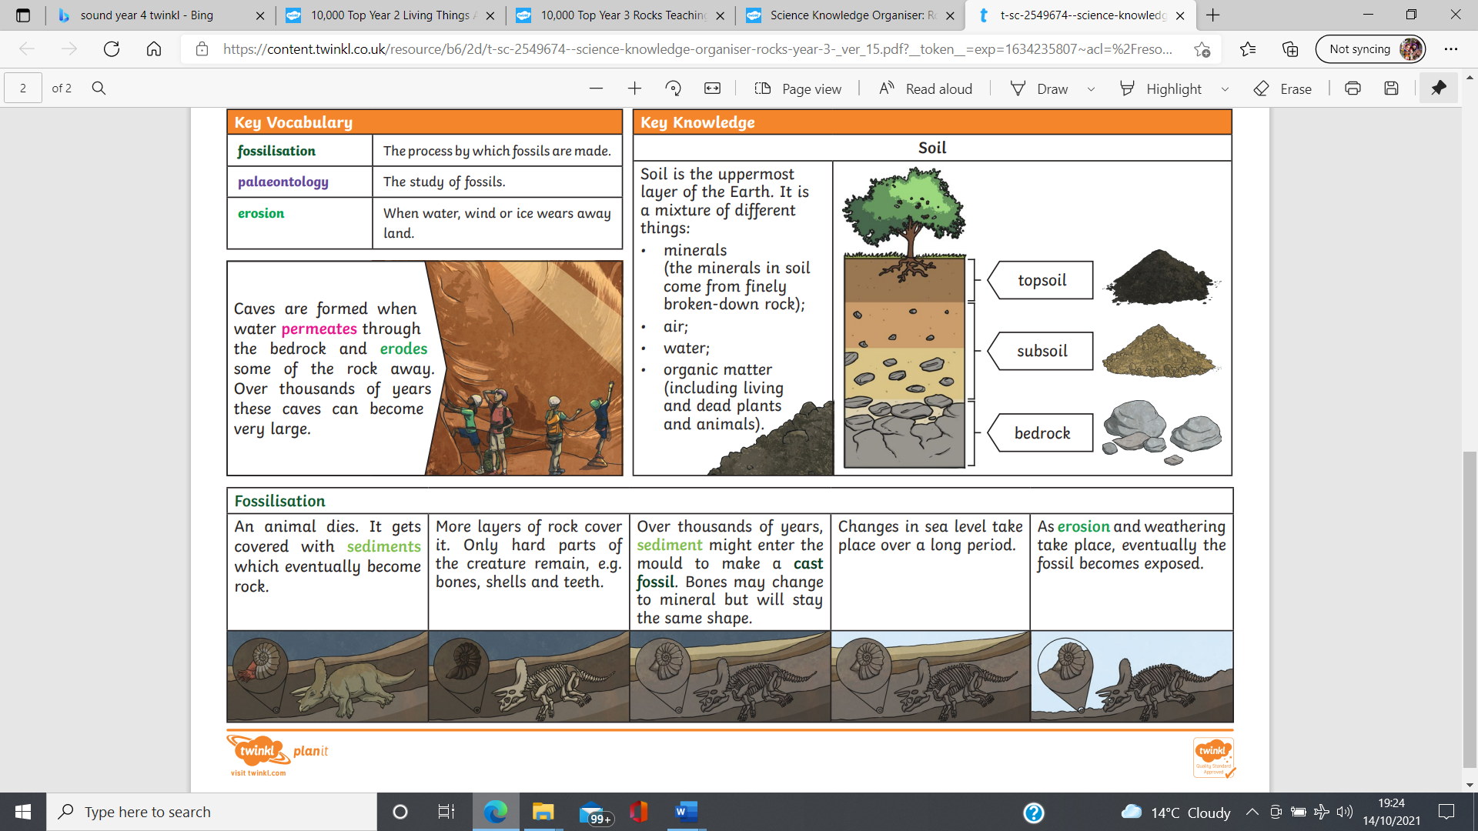  - To understand that fossils are the preserved remains of something that was once alive! To know that a dead animal or plant had become trapped within rock and buried over time. | Nice to know knowledge:  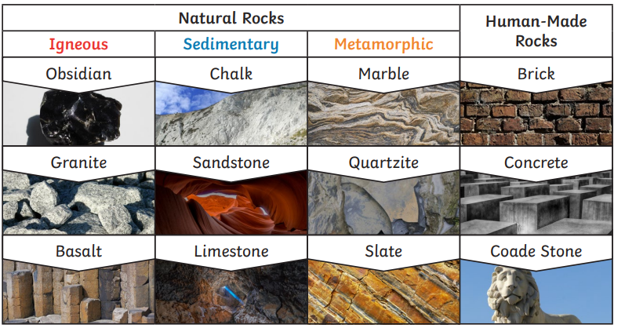  The Rock Cycle  Rocks are constantly changing in what is called the rock cycle. It takes millions of years for rocks to change.  Here is an example of the rock cycle describing how a rock can change from igneous to sedimentary to metamorphic over time.  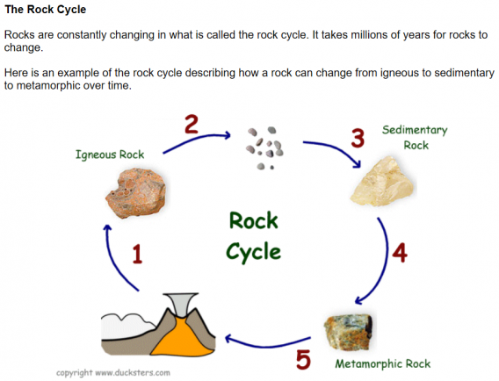
soil | Soil is a combination of a range of materials, including ground up pieces of rock, particles from dead plants and animals, air and water.
igneous | Igneous rocks are formed from magma. Sometimes, magma cools under the earth’s surface and forms rocks. Other times, magma spurts out of volcanic eruptions as lava and cools down, mixing with other minerals to form rocks on the surface. Igneous rocks are usually very hard and non-porous.
metamorphic | Metamorphic rocks are formed when rock becomes warm enough to bend and mould, but not enough to become liquid. Due to this, they can often form interesting shapes! Like igneous rocks, metamorphic rocks are often non-porous.
sedimentary | Sedimentary rocks are formed when small particles of mineral are washed down rivers, streams or lakes. This sediment becomes squashed with more and more layers added each day. They take millions of years to form. Sedimentary rocks are porous meaning that they let water through.
sediment | Sediment is small pieces of material which are the product of erosion. They usually sink to the bottom of liquids or are moved around by air, water or gravity.
permeable | Permeable materials allow liquids or gases to pass through them.
impermeable | Impermeable materials are water tight and air tight, not allowing any liquids or gasses to pass through.
fossils | Fossils are the preserved remains of something that was once alive! formed when dead animals or plants become trapped within rock by being buried by sediment over time.
fossilisation | Fossilisation is the process in which fossils are formed.
Erosion | Erosion is the gradual wearing away of a material due to the effects of wind, water or other natural agents.
magma | Magma is a hot underground liquid composed of molten rock and is stored in the Earth’s crust.
lava | Lava is magma that reaches the Earth’s surface through volcanic eruptions!

