  Year 3  Autumn 1: The Stone Age |  |  | 
Vocabulary
Ancestor | A relative that lived a long time ago. | Need to know knowledge:  - Know that ‘prehistory’ means that time before people started writing. Prehistory is split up into the Stone Age, Bronze Age and Iron Age.  - Know that historians and archaeologists study prehistory and look for evidence to understand what life was like in the past.  - Know that our species is called homo sapiens.  - Know that the Stone Age is split into three different periods of time:  - Palaeolithic  - Mesolithic  - Neolithic  - Know that the Bronze Age came after the Stone Age. People made tools out of metal rather than flint. The Bronze Age started about 4000 years ago.  2  - Know that the Iron Age came after the Bronze Age. The Iron age began about 800 BC. People in the iron Age are called Celts.  - The Romans invaded Britain in 43AD. This was the end of prehistoric Britain. | Nice to know knowledge:  1  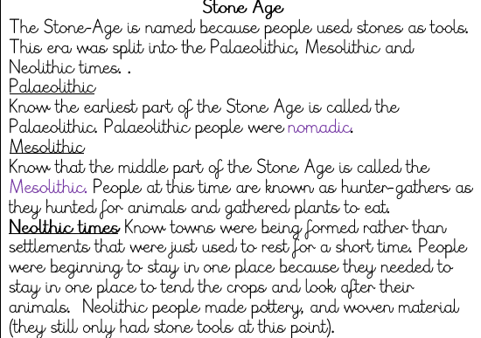  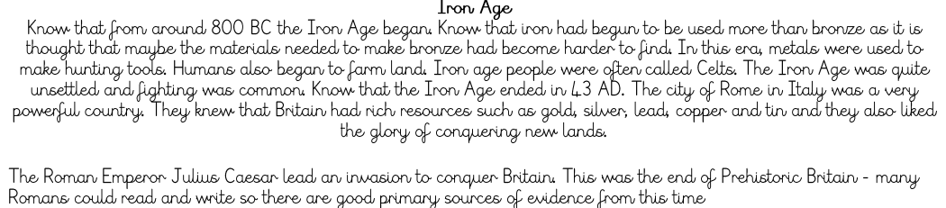  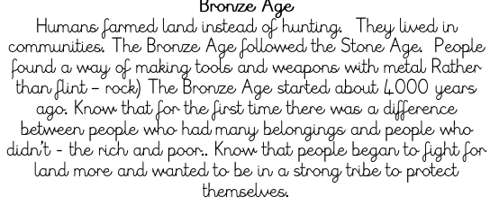  3
Homo sapiens | Human species.
Prehistoric | A time before humans started writing.
Tribes | A group of related people living together.
Hunter gatherer | A human who survives by foraging for food.
Nomadic lifestyle | A lifestyle which involves moving around and following ‘food’.
Settlement | Where people live and build their homes. Most early humans lived in caves.
Celts | A group of people who lived in the Iron Age.
Palaeolithic | The Old Stone Age. This started 2.5 million years ago to 10,000 BC.
Mesolithic | The middle Stone Age period. 10,000 BC – 5000 BC.
Neolithic | The final Stone Age period. This ended in 2000 BC. Around 4000 BC, people started farming.

