  Year 4  Autumn 1: Sound and Hearing! |  |  | 
Vocabulary

Sound | Sound is a type of energy caused by a vibration which travels through air, water or solid matter as a wave. They can be heard when the wave reaches and enters a human or animal’s ear. | Need to know knowledge:  - To understand that ‘sound’ is a type of energy caused by a vibration which travels as a wave.  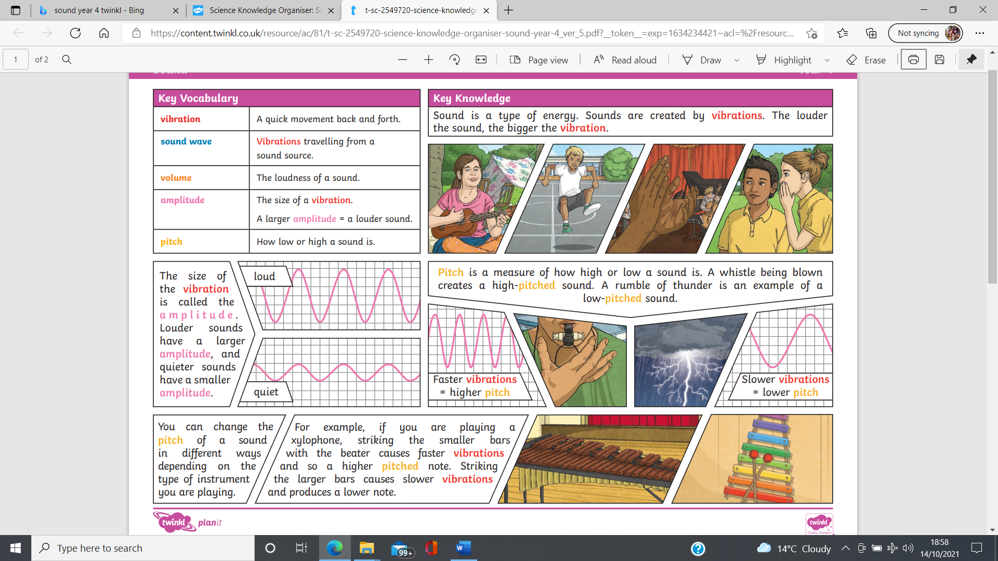  - To know that a vibration is a quick movement back and forth.  - To know that sound can be heard when the wave (vibration) travels from the sound source and reaches and enters the ear.  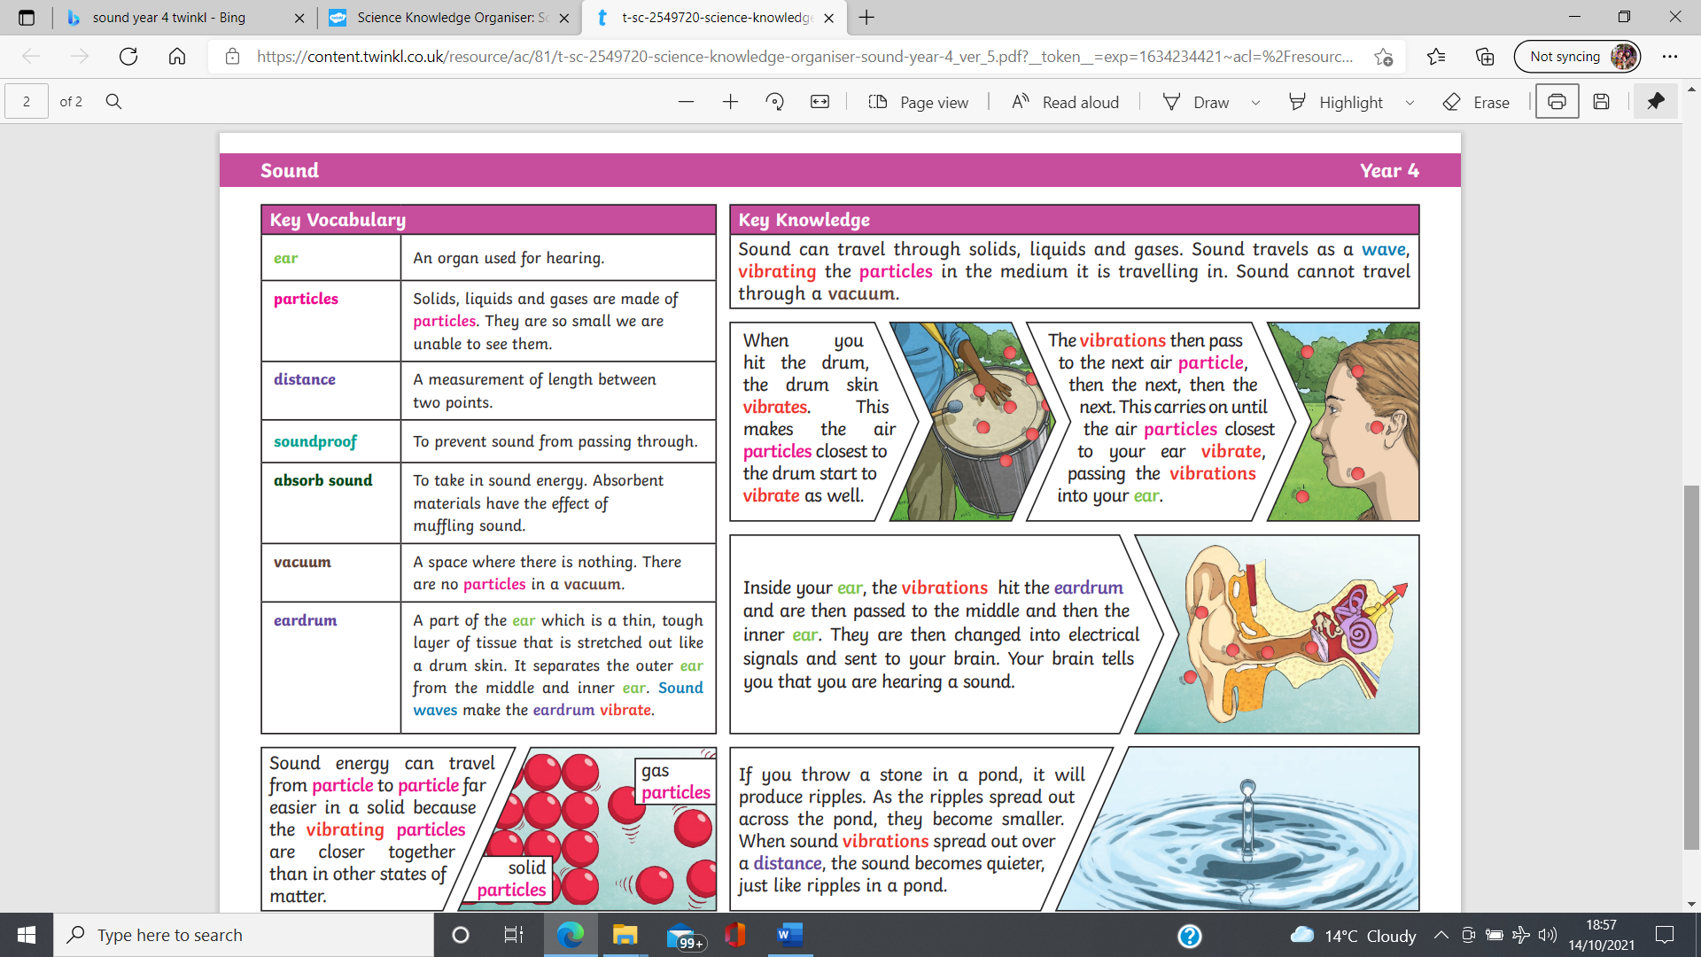  - To understand that volume is how loud or quiet a sound is.  - To begin to understand the terms ‘amplitude’ and ‘pitch’ attempting to discuss, using simple terms, what is happening. | Nice to know knowledge:  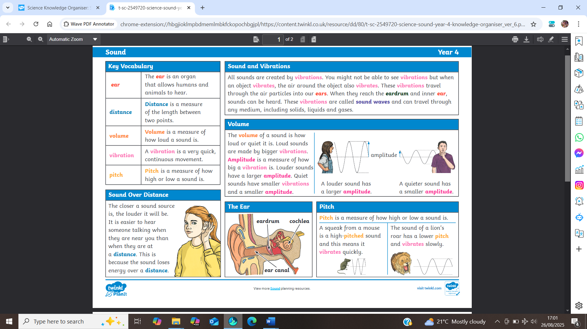
Ear | The ear is an organ (or body part) of a human or animal which is sensitive to sound in other animals. Ears give us the sense of sound or ‘hearing’.
Eardrum | The eardrum is a thin, cone-shaped membrane (layer of thin skin) that separates the external ear from the middle ear. The eardrum vibrates in response to sound waves.
Vibration | Vibration is a quick movement back and forth.
Vacuum | Vacuum is an empty space. It is a space where there is nothing – no air, water or gas particles at all.
Sound wave | Sound waves are vibrations which travel from a sound source to the ear.
Amplitude | Amplitude is a measurement. It measures the size of the vibration. Louder sounds have bigger (taller) amplitudes and quieter sounds have smaller (shallower) amplitudes.
Volume | Volume measures how loud the sound is!
Pitch | Pitch measures how high or low a sound is. Faster vibrations create a higher pitch and slower vibrations create a lower pitch.
Particles | Particles are tiny pieces of matter that make up solids, liquids and gases. They are so small we are not able to see them.
distance | Distance is the measurement of length from one point to another.
Sound proof | The act of soundproofing prevents vibrations causing sound from passing through materials.
Absorb sound | To take in sound energy and storing or ‘trapping’ it. Absorbent materials have the effect of muffling sound as it struggles to pass through the material smoothly.

