  Year 4  Autumn 1: Europe Explorers |  |  | 
Vocabulary
Europe | The second smallest continent in the world. | Need to know knowledge:  - Know that there are 50 countries in Europe.  - Know that Italy is a country in southern Europe and that it is part of the Mediterranean.  - Know that climate is weather in a particular area. The climate in Italy is warmer that the UK as Italy is closer to the Equator. This is the Mediterranean climate (mild winters, with hot, dry summers).  - Know that a mountain is a physical landform which rises above the land. Italy has two mountain ranges:  - The Alps  - The Apennines  - Know that a volcano is an opening in the Earth’s structure from which molten rock bursts out. There are 3 active volcanoes in Italy.  - Know three cities in Italy:  - Rome (Capital city)  - Milan  - Venice | Nice to know knowledge:  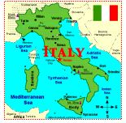  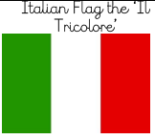  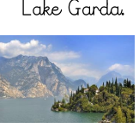  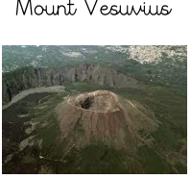  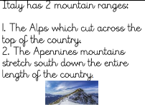  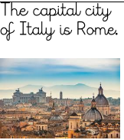  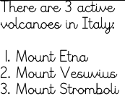  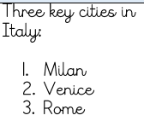
Continent | A very large area of countries, such as Asia.
Country | An area of land ruled by a government.
Population | The amount of people living in a particular place.
Terrain | The type of land and physical landforms there.
Capital City | The city where the government for that country is found.
Mountain | An area of land that rises above 300 metres high.
Volcano | A mountain like feature which holds magma.
Human Feature | A feature made by a human.
Physical Feature | A natural feature.
Climate | The weather in a particular area.

