
Castle Hill Primary School Writing Knowledge Organiser
Year 5 Autumn 1
Genre: Newspaper report
Genre Features
Textual features (What does the text look like?) |  |  | 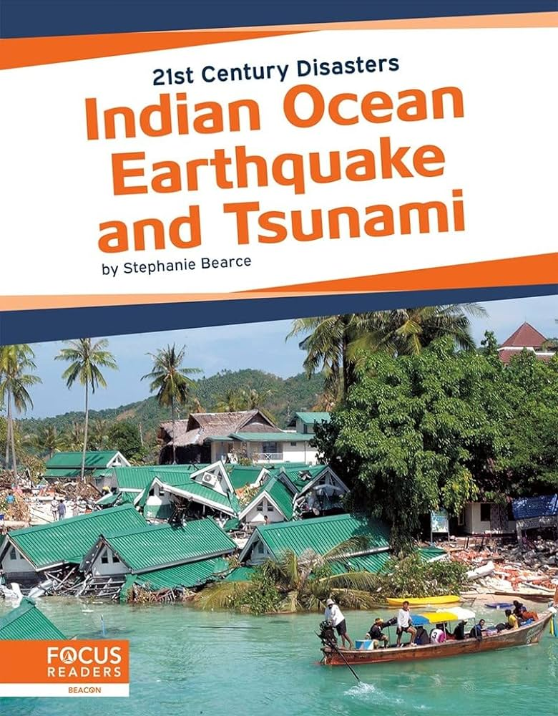  Stimulus: Indian Ocean Earthquake and Tsunami |  | Grammar features (What is used in the sentences?)
Main heading (title) | It tells you what the text is about. |  |  |  | Present perfect tense | This tense tells you what has happened. It uses Has (or have) + verb, eg:  Has won  Have beaten  Has played |  | Indonesia has been hit by a giant tsunami from the Indian Ocean.
Caption | A sentence under a picture to tell you what the picture is about.
Main body | The main paragraph of the newspaper report which tells you what has happened.
Present perfect tense | This tense tells you what has happened. It uses Has (or have) + verb, eg:  Has won  Have beaten  Has played |  |  |  | Inverted commas | Speech marks are used to show exactly what was said. This is called direct speech. “C,” said ____  New speaker = new line. |  | “I knew what it was immediately,” she said.
Introduction | The first paragraph which tells you ‘who’, ‘what’ and ‘why’ you are writing.
Direct speech | Speech marks are used to show exactly what was said. This is called direct speech. “C,” said ____  New speaker = new line.
Past tense | Verbs that show the action is has already happened. They often have the suffix ‘ed’. |  |  |  | Subordinating clause (before main clause)  (I SAW A WABUB) | They join a main clause and subordinate clause together. This makes a compound sentence. The subordinate clause can come before the main clause and a comma is used. |  | While people were relaxing on the sparkling beach, waves were gathering in the distance.
Third person | Using ‘he’, ‘she’, ‘it’ and ‘they’ as subjects in your writing.
Chronological order | Time order, starting with what happened first.
What do the children need to know before they write? What can they investigate?
Introduction:  - What happened?  - Who did happen to?  - Why did it happen? |  | Main body:  - What has happened?  - When did happen?  - Who has it happened to?  - Why has it happened?  - What happened next?  - What happened after that? |  | Effects:  - What are the consequences?  - Describe what the effects are.  - Why is it a problem?  - What could happen next? |  |  | Interview: Speaking to Tiilly Smith  - Who are you speaking to?  - Why are you speaking to them?  - What do they have to say?

